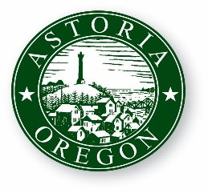
AGENDA

ASTORIA CITY COUNCIL WORK SESSION
TUESDAY, OCTOBER 17, 2017
9:00 AM
2nd Floor Council Chambers
1095 Duane Street Astoria OR 97103

- CALL TO ORDER

- ROLL CALL

- discuss strategic planning & visioning

- ADJOURNMENT

- EXECUTIVE SESSION

  - ORS 192.660(2)(i) – Performance Evaluation

